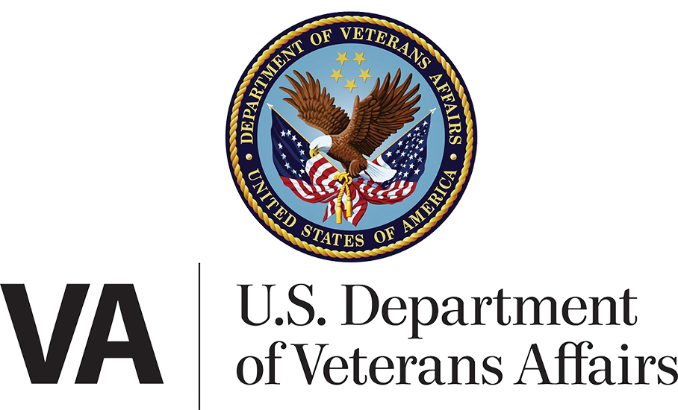

Department/CTO Health Team

June 4, 2024 | My HealtheVet on VA.gov Portal and Landing Page

Version 2.0

Revision History

| **Date** | **Version** | **Description** | **Author** |
| --- | --- | --- | --- |
| 03/21/2023 | 1 | Landing Page debut | Marci McGuire |
| 06/04/2024 | 2.0 | Integration of tools on VA.gov w/MHV navigation | Wes Rowe |

Table of Contents

1. Product Overview 4

New: Integration of tools into VA.gov 5

New navigation element across the My HealtheVet-on-VA.gov portal 6

How users can reach the My HealtheVet Portal and Landing Page 6

Starting from VA.gov 6

2. User Access 7

Alert case: sign-in credential needs identity verification 7

Alert case: no access to My HealtheVet 8

If a user sees this yellow alert but believes it to be erroneous: 9

3. Navigation and primary functionality 9

My HealtheVet secondary navigation 10

Medical Records is still on the “previous version” of the My HealtheVet website 10

The “Records” option in the My HealtheVet navigation bar gets special treatment. 11

The Medical Records box on the landing page gets special treatment also. 11

Landing page 12

Links within landing page 14

4. Common issues and error messages 15

## 1. Product Overview

The My HealtheVet-on-VA.gov landing page serves as a front door to VA.gov’s health-related applications. At the launch of the landing page in March of 2023, many of the health tools it linked to were still located on the My HealtheVet National portal website (secure messaging, medications, and medical records). Only the Appointments tool was located on VA.gov at that time.

In Veteran-facing content within the My HealtheVet-on-VA.gov portal, **the My HealtheVet National Portal website is referred to as “the previous version of My HealtheVet.”** (Its URL is [myhealth.va.gov](http://myhealth.va.gov).)

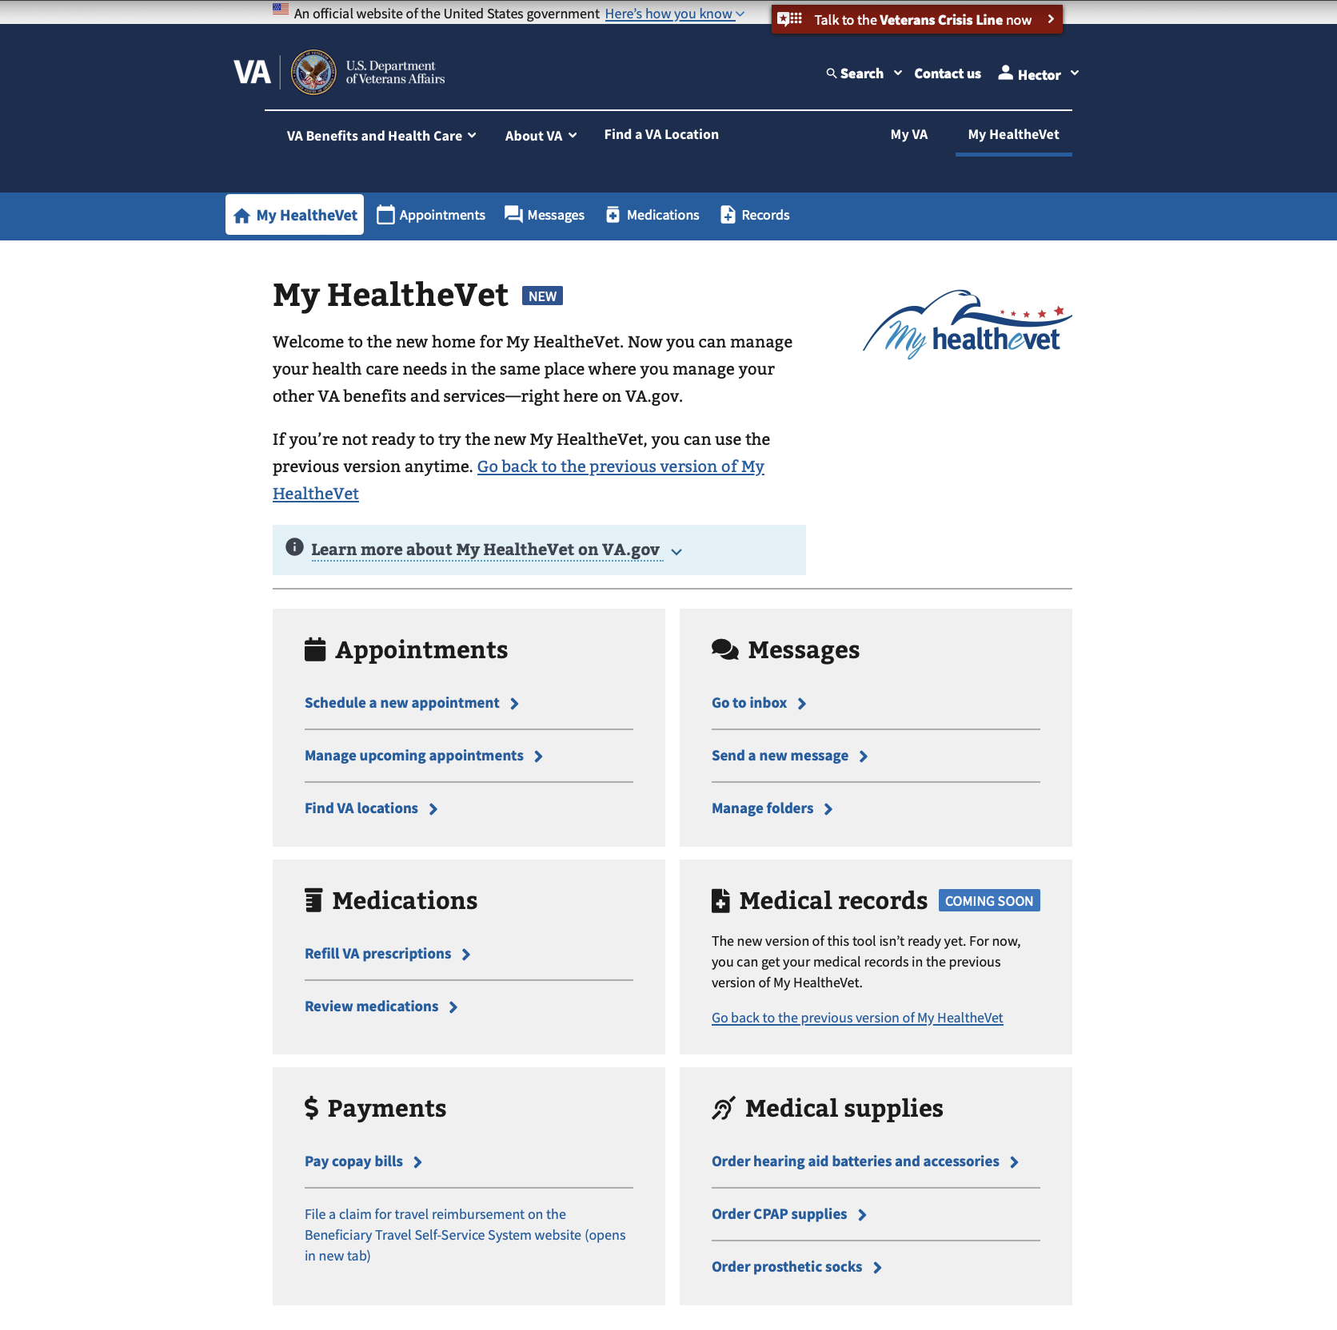

**Note the “NEW” tag at the top of the page.** This has been added to the H1 header of the landing page and also the top-level pages of the Secure Messaging and Medications tools. (The Medical Records page on VA.gov gets a “COMING SOON” tag.) When you receive calls with inquiries about My HealtheVet tools, this may be a useful indicator to confirm that the caller is on the new VA.gov version of a tool.

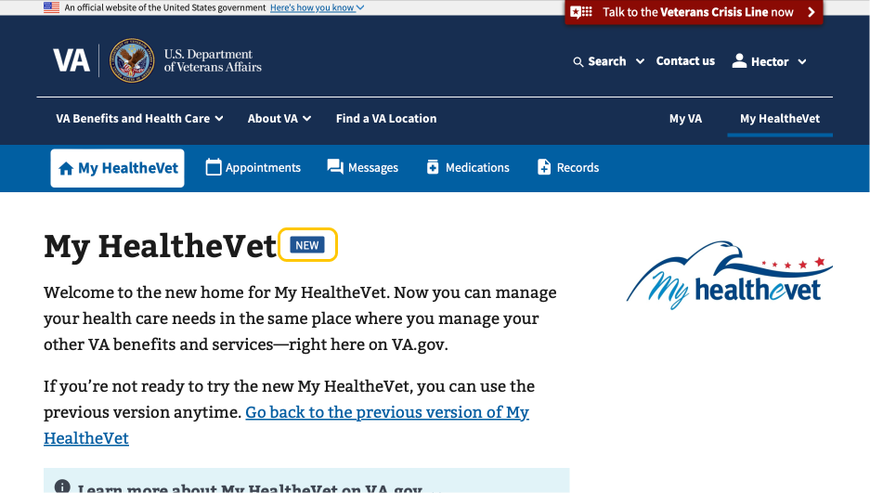

### New: Integration of tools into VA.gov

In early June 2024, the My HealtheVet-on-VA.gov portal will become a more self-contained, health portal-like experience. At that point, three tools will be available on VA.gov:

* Secure messaging
* Medications
* Appointments

(Note: Medical Records is not yet available on VA.gov. See Section 3 for details.)

#### New navigation element across the My HealtheVet-on-VA.gov portal

The new My HealtheVet navigation bar is present on every page within the My HealtheVet-on-VA.gov portal, on both desktop and mobile devices. The navigation bar links to four tools - Appointments, Messages, Medications, and Medical records - as well as to the My HealtheVet landing page.

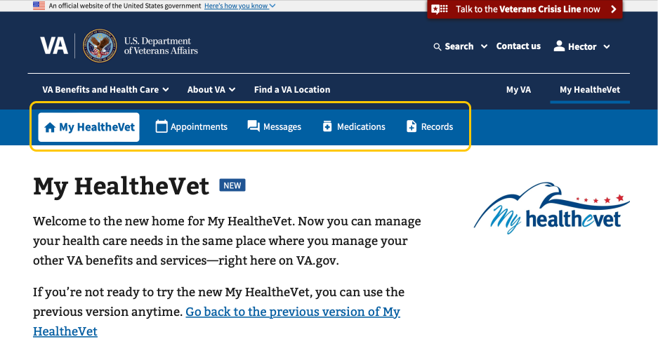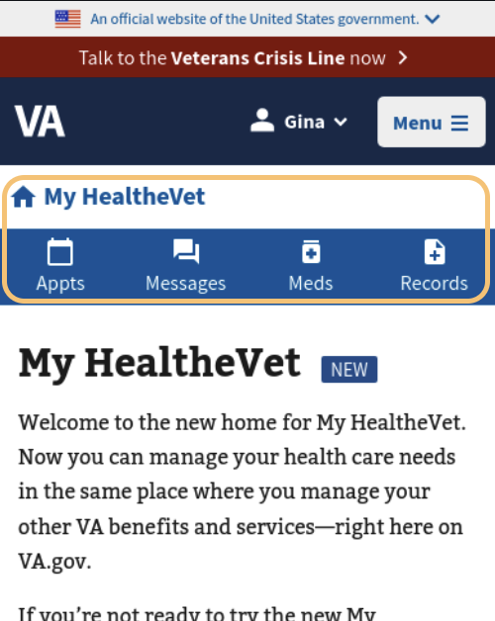

### How users can reach the My HealtheVet Portal and Landing Page

#### Starting from VA.gov

**Desktop users:** Those who sign in to VA.gov on a desktop computer will see a “My HealtheVet” link in the header, which will take them directly to the My HealtheVet-on-VA.gov landing page. This link is enabled for all signed-in desktop users, regardless of whether or not they receive VA health care benefits.

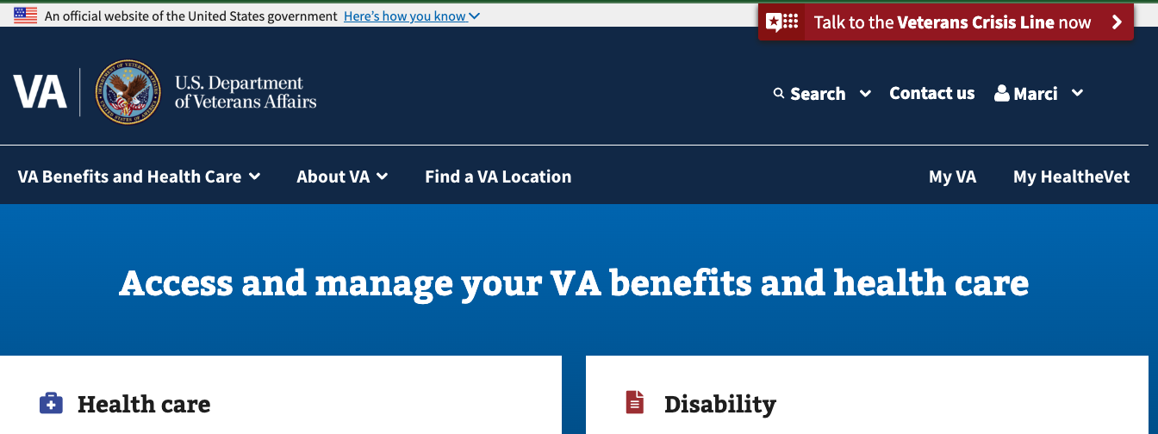

(continues on next page)

**Mobile users:** Those who sign in to VA.gov on a mobile device will need to click on the personal name dropdown menu at the top of the screen. There they will see the My HealtheVet link, which will take them directly to the My HealtheVet-on-VA.gov landing page. This link is enabled for all signed-in mobile users, regardless of whether or not they receive VA health care benefits.

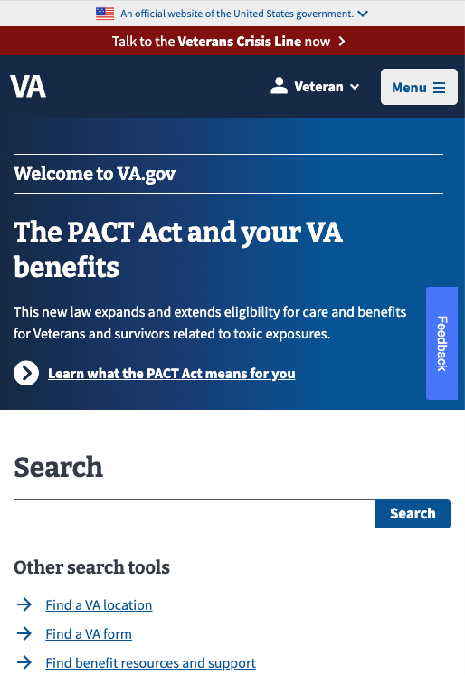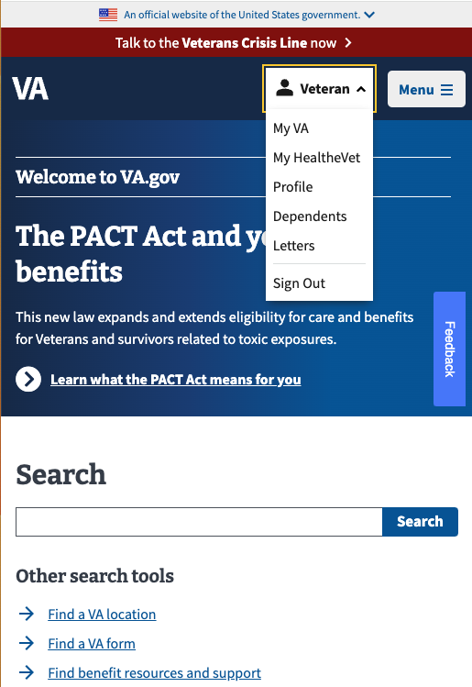

## 2. User Access

For a user to view the complete version of My HealtheVet-on-VA.gov landing page (including links to health tools as described in this document), they must meet the following criteria:

* Signed into VA.gov with an identity-verified credential
* Previously registered at a VA facility

If these conditions aren’t met, the alerts below will display and the links to health tools will not show. In this situation, some useful links will still appear below the alert (as in screenshots below).

### Alert case: sign-in credential needs identity verification

If a user’s signed-in credential is not ID-proofed (i.e., LOA3), the six main boxes on the landing page will be replaced by an alert informing the user of the issue and providing a link to instructions for verifying their identity. The MHV secondary navigation bar is also hidden, since these tools require an identity-proofed credential.

Note: By August 1, 2024, we anticipate adding more informative alerts about the identity-verification process. These alerts will be more tailored to the user’s specific credential and circumstances, with the intention that all identity-related alerts on the MHV landing page will provide clear instructions for the user’s specific situation.

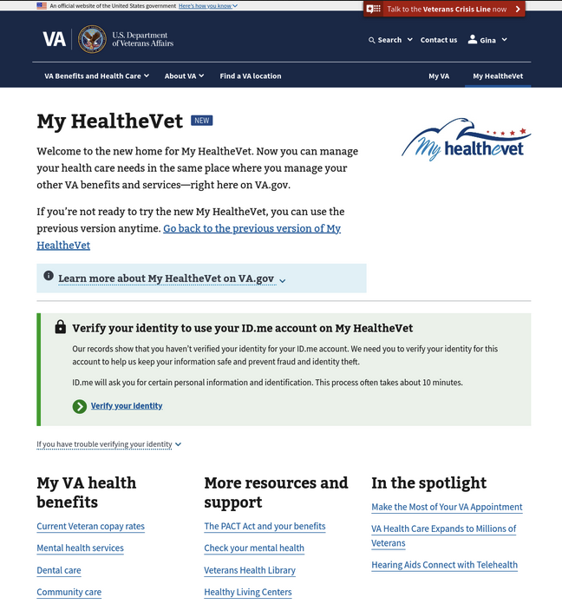

The “Verify your identity” link will take the user to a Resources & Support page explaining how to verify their identity for either a Login.gov or ID.me credential.

**If the user signed in with a My HealtheVet credential** – they will need to upgrade their MHV credential to be identity-verified (LOA3). The only way to do this is to create a Login.gov or ID.me credential and identity-proof it. (An alert specific to this situation will be in place by August, 2024.)

### Alert case: no access to My HealtheVet

A user who has successfully signed in with an identity-proofed (LOA3) credential will see this alert if the data shows that they are not registered at a VA facility. We detect this by checking whether any facilities are associated with their VA record. As the alert states, anyone who has received care at a VA facility or has a pending application for health care benefits should be registered with a facility.

NOTE: As of June 10, 2024, there is a **known issue** where the user sees this alert erroneously. This can happen when a user is using a new Login.gov or ID.me credential which has never been signed into the old version of My HealtheVet at [myhealth.va.gov](http://myhealth.va.gov). See the next section for remedy (“pairing” their credential with their My HealtheVet account).

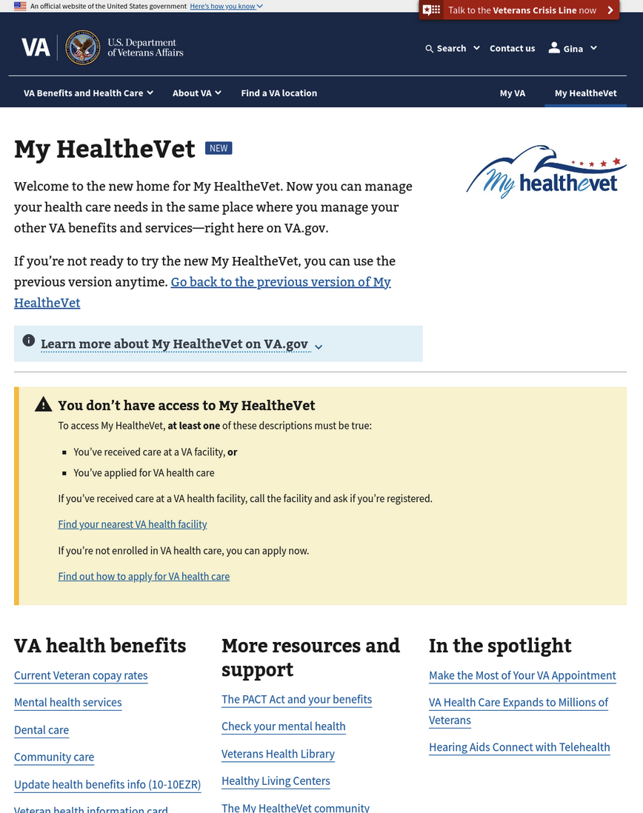

#### If a user sees this yellow alert but believes it to be erroneous:

If the user signed in with a new Login.gov or ID.me credential – they may need to “pair” it with their My HealtheVet records. To do so, ask them to follow these steps:

1. Using the same Login.gov or ID.me credential, sign into the old version of the My HealtheVet national portal website at [myhealth.va.gov](http://myhealth.va.gov). This step connects their credentials with their health record.
2. Sign into VA.gov and return to the My HealtheVet landing page.

In other scenarios, they may need to call their local VA facility.

## 3. Navigation and primary functionality

### My HealtheVet secondary navigation

The new MyHealtheVet website contains a new secondary navigation feature at the top of the portal page and below the main VA.gov navigation menus. This set of tabs is persistent across all use cases within the portal on both desktop and mobile devices, visible as users switch between tools for easy access and viewing. The navigation tabs link to the main page of each health tool, and remain highlighted while users are using each tool. Each of the tool applications link to the new, portal-integrated experiences with the exception of Medical Records, which will lead users to a temporary page that is further explained below.



### Medical Records is still on the “previous version” of the My HealtheVet website

The new version of Medical Records is not yet ready. Until it is ready, we will direct users to go to the “previous version” of the tool on the National Portal. We have made this clear in several ways:

#### The “Records” option in the My HealtheVet navigation bar gets special treatment.

When a user clicks on “Records” in the navigation bar, they’ll see a landing page that explains that the new tool is not yet available, what to expect with the new tool, and that for now they should use the previous version of Medical Records. It then offers them a link that will take them to the previous version of Medical Records.

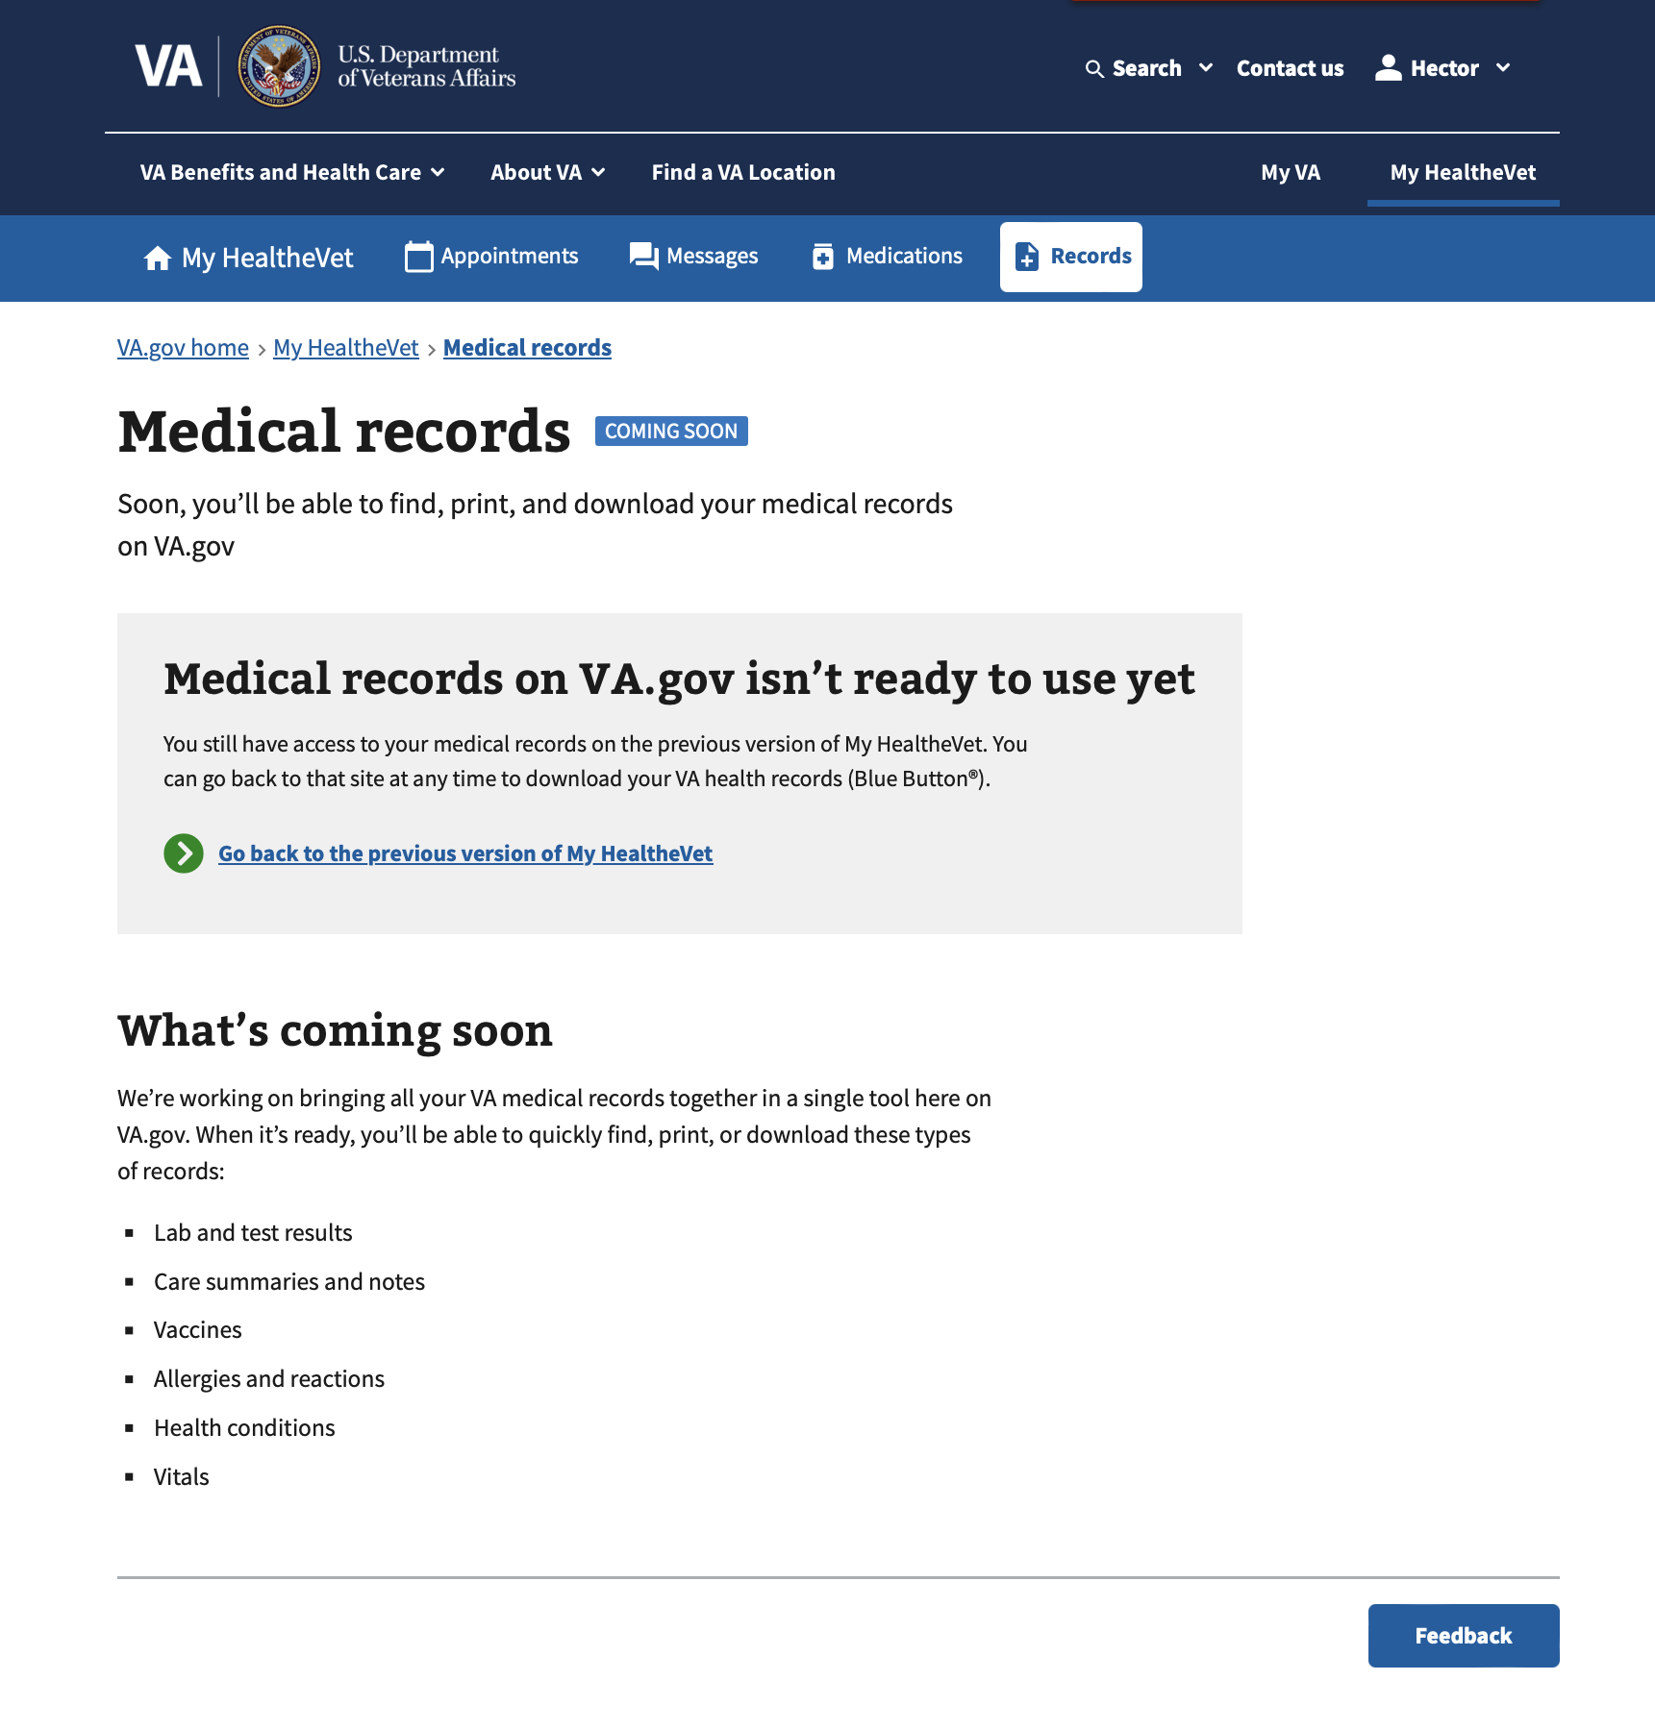

#### The Medical Records box on the landing page gets special treatment also.

Content there briefly explains that users need to use the previous version of medical records for now and offers a link directly to “the previous version.” The Records box also has the “coming soon” tag to indicate that a new version of the tool is on the way.

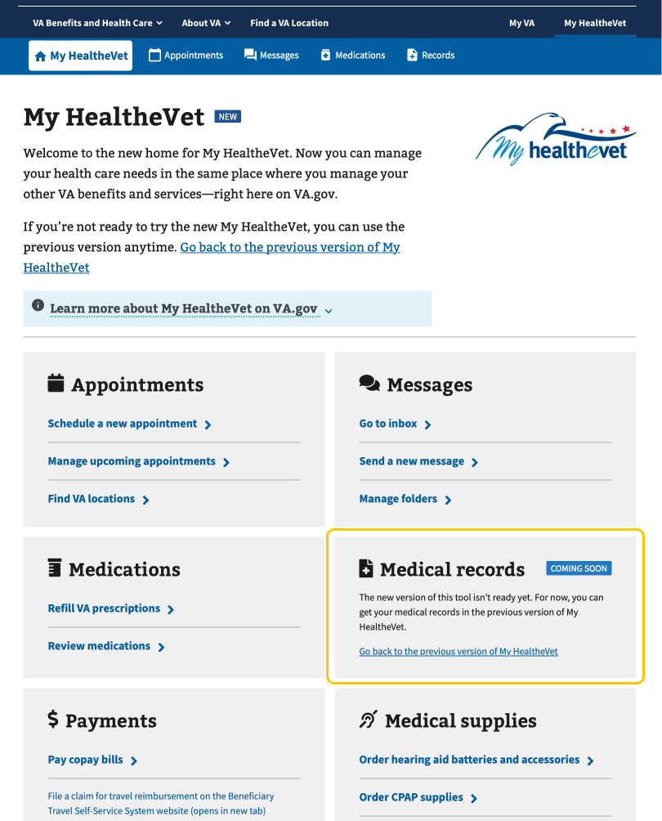

### Landing page



The “NEW” tag at the top of the page has been added to the H1 headers of the landing page, Secure messages, and Medicaitons to indicate to users they’ve navigated to the new VA.gov version of a tool.



Users have two options to select from to go back to the previous My HealtheVet website: **1) click the link in the second main paragraph on the landing page** (labeled “Go back to the previous version of MyHealtheVet”), or **2) click** **the link located within the expandable alert** (labeled “Learn more about MyHealtheVet on VA.gov”). See respective screenshots below.

1. Click the link in the second main paragraph **on the landing page**:

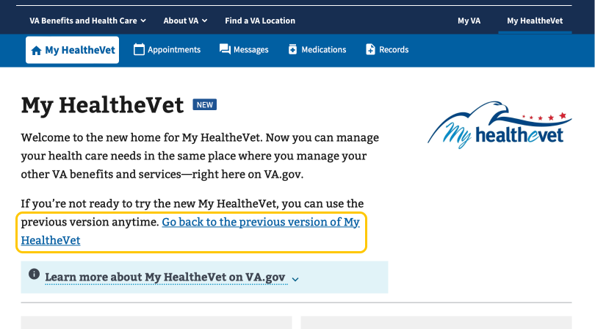

1. Click the link **within the expandable alert**:

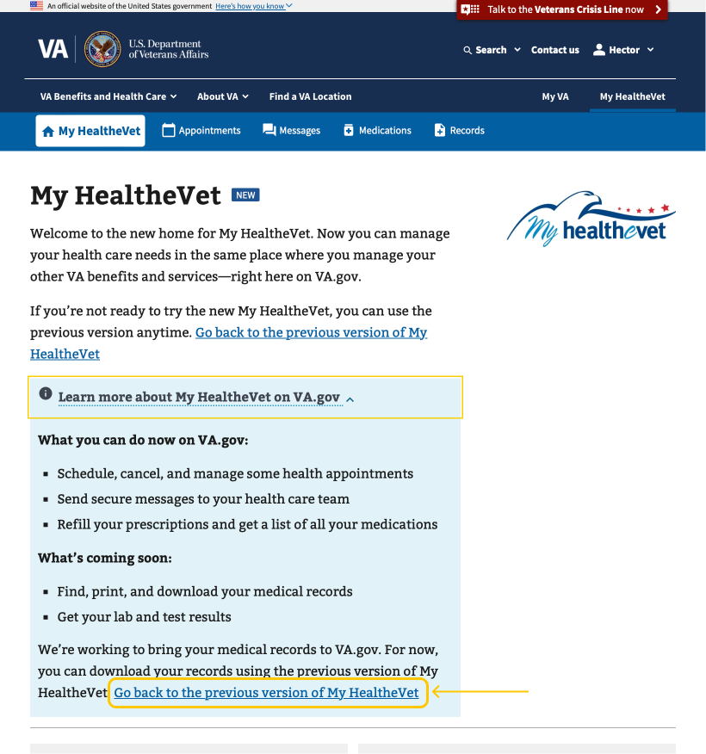

### Links within landing page

The links are generally self explanatory, with the main features within each tool displayed as hyperlinks. The exception is the Medical Records tool, which as previously mentioned doesn’t yet have a new version on VA.gov. A single link inside that box takes users to the old version of the My HealtheVet website at myhealth.va.gov.



## 4. Common issues and error messages

Neither the My HealtheVet landing page nor navigation bar relies on back-end services in order to display. Therefore, there are no common issues or error messages apart from the account-related topics covered in Section 2, User Access.